# ConvertStep

**Objective:**

It is used to Convert data from one format to another.

**Attributes:**

|  |  |
| --- | --- |
| **Attributes** | **Description** |
| convert_from | To select from which data format need to convert |
| convert_to | Used to select to convert data into which format |
| data | Used to enter data |
| value_type | To select type as free marker template or handlebar |
| output_variable | Used to store the response of the request |

**Sample config.json:**

{

"workflows": [

{

"name": "convert",

"id": 200,

"trigger": "rest",

"expression": "convert",

"method": "GET",

"steps": [

{

"type": "start",

"id": 1,

"next": {

"start": "start"

}

},

{

"output_variable": "convert-output",

"value_type": "ftl",

"data": "{\"name\":\"rajnish\",\"address\":\"nalanda\",\"age\":\"31\"}",

"convert_to": "xml",

"convert_from": "json",

"type": "utils-convert",

"id": "start",

"next": {

"success": "convert-success",

"failure": "hangup"

}

},

{

"variable_name": "convert-output",

"http_response_code": "200",

"response_content_type": "content-type",

"value_type": "hb",

"type": "send",

"id": "convert-success",

"next": {

"success": "hangup",

"failure": "hangup"

}

}

]

}

],

"filters": [],

"server": {},

"plugins": []

}

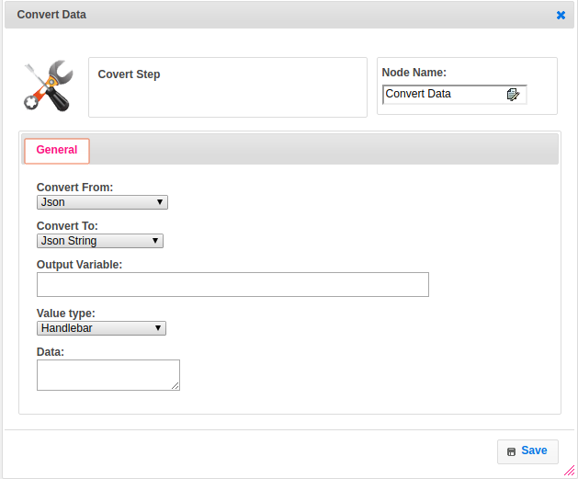

**Executor Description:**

* In executor class first it Reads the data and assign to JSONNode based on the convert_from data format(ex:xml,yml and json etc..). If there is any exception it will through invalid convert_from format.
* It convert the JSON node based on convert_to data format(ex:xml,yml and json etc..). If there is any exception it will through invalid convert_to format.
* Then it will store the converted data into map using output variable and returns status as success.(ex:xml,yml and json etc..)